Customer Search proceeding into Sell New Form
Step | Screen Shot
- Click Customer Search tab | 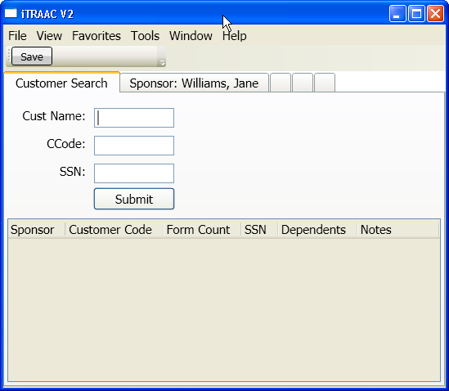
- Enter search criteria
e.g. F/L Name, CCode, Form#, SSN, Dependent’s Name
- Click Submit
- Search results return in a grid list below
e.g. columns: name, owning office, dependents
- Double click search result grid line item
- Sponsor tab opens | 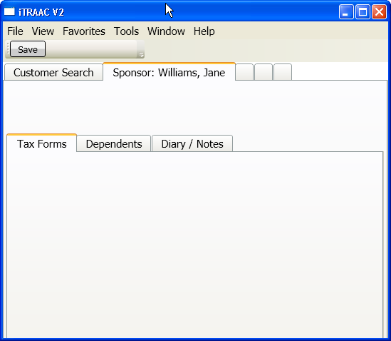
- Toolbar on Customer tab includes Sell New Form
- Modal popup for New Package
  - Enter Form Count, etc.
  - Click Submit
  - Total Price is displayed for customer payment
  - Force selection of Payment Method
  - Print Forms Confirmation [OK/Cancel]
  - Force confirmation acknowledgment of correct form info to both Customer and Agent
  - Popup closes
- New Package is added to the grid on the Purchased Forms tab
- Prompt for AutoClose [Yes/No] of the customer tab
  - [x] Always AutoClose ->saves in UserPrefs
- Search tab regains focus

